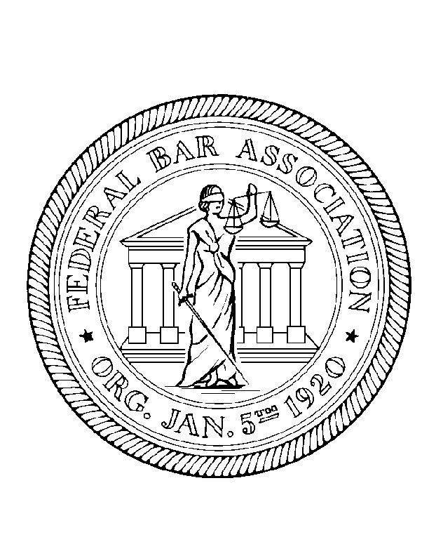
Minnesota Chapter of the
Federal Bar Association
Newer Lawyers Committee

Wednesday June 22, 2016 and Wednesday July 13, 2016
12:00 – 1:00 p.m.

The Honorable John R. Tunheim Chief Judge
United States District Court for the District of Minnesota

Summer Associate and Law Clerk Luncheon

Minneapolis Federal Courthouse, Courtroom 15
300 South Fourth Street, Minneapolis, MN

Name(s)
Firm/Organization
Email address

Prepayment is required. Please make checks payable to: Minnesota Chapter of the FBA.

Private Practice - $30 enclosed
Judicial/Government Clerk - $15 enclosed

Please indicate your menu choice:
Chipotle Chicken Sandwich – served with small salad, chips, cookie, and bottled water.
Honey Dijon Ham Sandwich – served with small salad, chips, cookie, and bottled water.
Spicy Southwestern Veggie Sandwich – served with small salad, chips, cookie, and bottled water.

Please indicate which luncheon you will attend:

June 22, 2016
July 13, 2016

Please RSVP with payment (made out to Minnesota Chapter of the FBA)
and lunch choice by Friday, June 10, 2016 to:

Paige Stradley
Merchant & Gould P.C.
3200 IDS Center, 80 South 8th Street
Minneapolis, MN 55402-2215
PStradley@MerchantGould.com

