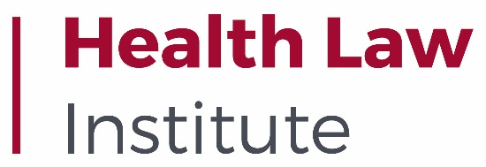
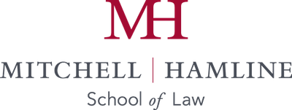

2024 Roy Snell Health Care Regulatory & Compliance Writing Competition Winners Announced

This year marked the 5th annual national Roy Snell Health Care Regulatory & Compliance Writing Competition. The competition attracted outstanding student participation from top law schools around the country.
All submissions were judged by a panel of independent legal and compliance experts. Neither the entrant’s identity nor academic institution were known to the judges. Top honors were awarded to the following students:
1st Place: Christina Dalton - University of Florida Levin College of Law
2nd Place: Matthew Martien – Mitchell Hamline School of Law
3rd Place: Darla Mueller - Mitchell Hamline School of Law
The Roy Snell Health Care Regulatory & Compliance Writing Competition recognizes law students for innovative, strategic, and sound approaches to tackling complex contemporary health care regulatory and compliance issues. The first-place winner receives a $5000 cash award, paid registration for the 2024 HCCA Annual Compliance Institute (valued at over $1,500) and up to $1500 in travel and conference-related expenses. The second-place winner receives a $3000 cash award, paid registration for the 2024 HCCA Annual Compliance Institute and up to $1500 in travel and conference-related expenses. The third-place winner receives a $1500 cash award, paid registration for the 2024 HCCA Annual Compliance Institute and up to $1500 in travel and conference-related expenses.
About the Competition
In keeping with Roy Snell’s keen interest in practical, realistic, and user-centered communication, as well as a commitment to efficiency and clarity in writing, this demanding competition requires students to analyze a hypothetical fact pattern (the Competition Problem) involving an organization facing multifaceted health care regulatory/compliance matters and draft two separate written work products to two different recipients within the organization. Students must analyze the facts presented, identify any and all regulatory/compliance concerns and advise the recipients of the two written work products. While these two written work products address the same hypothetical situation and subject matter, they are to be drafted with a specific audience/reader in mind. Content must be customized to a particular audience/reader to optimize understanding, engagement, and responsiveness. This year’s competition challenged students to draft a detailed internal legal memorandum and create a PowerPoint presentation.

The competition honors Roy Snell, the distinguished and highly regarded former CEO of the Health Care Compliance Association (HCCA) and the Society of Corporate Compliance and Ethics (SCCE), for his visionary leadership and extraordinary contributions to the field of Health Care Compliance. Roy Snell lends his name to the competition to support new and emerging leaders in health care compliance. For more information on Mr. Snell’s extraordinary legacy click here.

About the 2024 Problem

The 2024 problem, drawn from recent cases and enforcement actions, was an advanced, complex, and nuanced hypothetical involving a fictitious company caught in the crossfire of numerous legal, regulatory, and compliance concerns. Issues of kickbacks, false claims, transparency of payments, and health care fraud are recurring themes throughout the problem. Additionally, the themes of individual executive accountability and conspiracy were also present in many aspects of the hypothetical.
About the Judging Panel
Thank you to the competition panel of independent judges who volunteered their time and expertise:
David Graham, JD
Senior Counsel, Gardner Law
Melissa Hunt, JD, LLM
Senior Director, Arcus Biosciences
Business Partner and Health Law Attorney
Michael Loucks, JD
Retired Partner, Skadden, Arps, Slate, Meagher & Flom LLP and Affiliates
Bob Wade, JD
Partner, Nelson Mullins

About the Competition Sponsor
The Roy Snell Health Care Regulatory & Compliance Writing Competition is made possible in part by generous support from the Health Care Compliance Association. To learn more about HCCA please click here.
2025 Roy Snell Health Care Regulatory & Compliance Writing Competition
Information on the 2025 Roy Snell Health Care Regulatory & Compliance Writing Competition will be available in September 2024. All students interested in health care compliance and regulation are encouraged to compete.
About Mitchell Hamline School of Law & The Health Law Institute
With roots dating to 1900, Mitchell Hamline School of Law was established in December 2015 through the combination of William Mitchell College of Law and Hamline University School of Law. It is the largest law school in the region, with approximately 1,200 students and 40 full-time faculty. It has nationally ranked offerings in alternative dispute resolution, health law, part-time programs, and clinical training; an array of certificates.
Mitchell Hamline’s Health Law Institute, established in 2006, educates students through specialized courses, certificates of study, moot court competitions, and experiential learning opportunities. The institute bridges the gap between health law scholarship and policy through engagement, collaboration, and innovation. It is a hub for the health law community, providing programs, training, educational opportunities, events, and symposia for law students, attorneys, health care practitioners, and business professionals.

