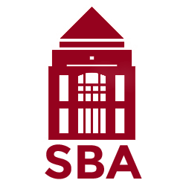
Declaration of the Student Bar Association
After a survey of our members, the Mitchell Hamline Student Bar Association has voted unanimously to adopt the following positions:
1. All doors at MH should be accessible to students via keycard.
Students surveyed reported that they are most concerned about being robbed, raped, and attacked in the areas surrounding the school. Quicker access to the school reduces these concerns. Students, particularly students who have mobility challenges, are concerned about the distance they must walk outside between their cars and the school. During winter months, slippery sidewalks, snow drifts, and limited parking further exacerbate these issues.
2. The school should not implement turnstiles.
Turnstiles, even “accessible” turnstiles, will make entering the school slower, more congested, and more frustrating for students. This is particularly true for disabled students and students who use rolling bags. Additionally, turnstiles will make our school unwelcoming to alumni and visitors. The hope with turnstiles is to limit access to the school to individuals with IDs and have a mechanism to require visitors without an ID to register. There are less restrictive ways to achieve this outcome that the school should consider before taking the drastic step to install turnstiles.
Sincerely,
– The Mitchell Hamline Student Bar Association

