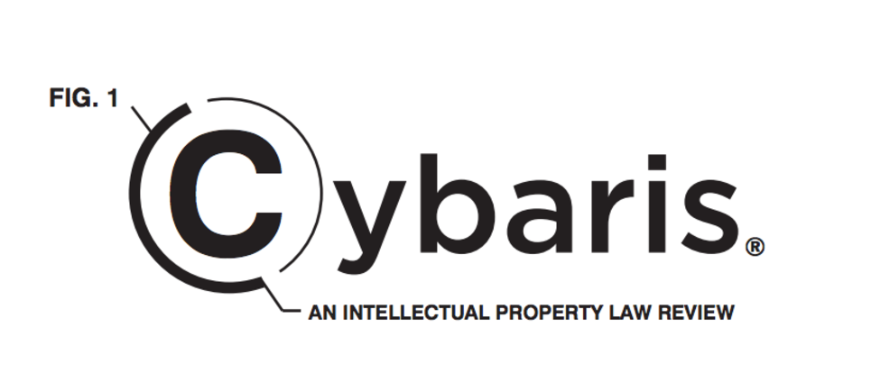

What is Cybaris®?
Cybaris® is a law review publication dedicated to Intellectual Property issues. Cybaris® publishes articles relating to patent law, copyright law, trade secrets law, and trademark law as well as how those areas of IP intersect with other areas of law.

How does Cybaris® work?
Cybaris® publishes two issues every year and the published articles address a range of intellectual property topics, including patent, copyright, trademark, and trade secrets. Throughout the academic year, Cybaris® Associate Editors work to edit every article we publish by checking the accuracy of the writing and citations against the Bluebook and the Chicago Manual of Style. Cybaris® Associate Editors then participate in a final put-together for each issue, during which all Cybaris® editors prepare the issue for publication.
During the fall semester, Cybaris® staff research and write an article on an IP topic of their choice, which is then considered for publication. Associate Editors can elect to use this article as their long paper. During spring semester, Cybaris® works with the Mitchell Hamline IP Institute to put on a spring symposium. Next year’s spring symposium will focus on patent law.

Why Cybaris®?
Cybaris® provides students an opportunity to refine important practical skills such as writing and editing while receiving two academic credits. Students can also elect to use their article for their long paper requirement.

Who can participate in Cybaris®?
Any student who will not be graduating Winter 2018 can become a Cybaris® Associate Editor! Intellectual Property coursework is not necessary. Cybaris® is not limited to students who are pursuing a career in intellectual property but is open to any student who would like to learn about intellectual property.

How does the Cybaris® Write-on Competition work?
Interested students will receive several articles on Friday September 21. Students will then have until 11:59 PM on October 21, 2018 to submit a short 3-5 page essay based on any of the articles and the essay must show some level of analysis. Because most students have not taken IP courses prior to the write-on process, we do not require an extensive amount of research on the topics but the submission must show some amount of analysis on any of the provided topics. Students must also submit a resume with their essay submission. The write-on instruction will include contact information for the editorial board

For any questions relating to Cybaris® and the Write-On Competition, please email:
Ryan Christen, Editor in Chief ryan.christen@mitchellhamline.edu

