Race and the Law: Past, Present, and Future
Come join MHBLSA as we host 4 well-respected professionals to answer questions about practicing in Minnesota and how race has impacted their practice!
In partnership with the Office of Diversity, Equity, and Inclusion.

Thursday Feb. 20 at 5:30-7pm in the Auditorium

Our 4 Panelists:

Dr. Hedy Walls: Chief Social Responsibility Officer of the YMCA Twin Cities
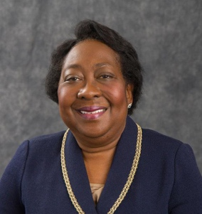
John Choi: Ramsey County Attorney
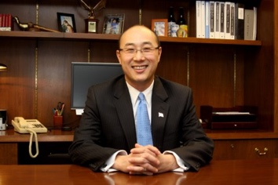
Judge Tanya Bransford: Hennepin County
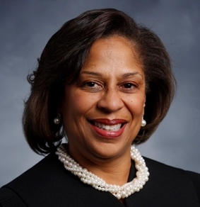
Judge Reynaldo Aligada: Ramsey County
