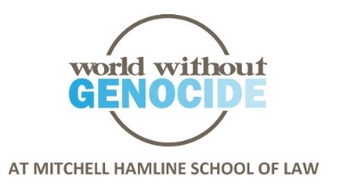

Fall 2020 Programs on Human Rights

World Without Genocide, a human rights organization at Mitchell Hamline School of Law in St. Paul, will host four public events in fall 2020 that will be held online through Zoom. Speakers include a Holocaust survivor, lawyers, human rights experts, and policy advocates.

- Wednesday, September 30, 7:00-9:00 pm CT, talk, America v. China: World Domination and the Genocides in Tibet and of the Uyghurs. This program examines the shift in global power from the United States to China and China’s corresponding impunity in carrying out violence against the people in Tibet and the Uyghurs in Xinjiang province, western China.
- Thursday, October 22, 7:00-9:00 pm CT, talk, The Global Decline of Human Rights and Freedom of the Press. Speakers will address the decline of human rights in countries around the world, including the United States, Poland, Hungary, India, and Turkey; the grave risk to journalists for attempting to report about the crises in Sudan, Syria, Pakistan, Philippines, and elsewhere; and the extreme danger to journalists who have been jailed during a global pandemic.
- Tuesday, November 17, 7:00-9:00 pm CT, talk, From the Nazis’ Jew-Free Cities to Poland’s Gay-Free Cities: The Spread of Hate Today. This program examines the failure to protect human rights during the Holocaust, when Jews were deported to their deaths, and again today, in the face of increasing governmental targeting of members of the LGBTQ community both abroad, as in Poland’s label of ‘gay-free’ on more than a hundred municipalities, and in the United States.
- Wednesday, December 2, 7:00-9:00 pm CT, talk, Genocide and Crimes Against Humanity: Punishing and Preventing the World’s Worst Crimes. This course addresses the failure by states around the world to prevent mass atrocities against their own and other civilians through perpetrating genocide and crimes against humanity. The course explains the origin of the term ‘genocide,’ the development and adoption of the UN Convention on the Punishment and Prevention of the Crime of Genocide, efforts to develop a similar convention for crimes against humanity, and the major international tribunals that prosecute perpetrators of these crimes. Genocides and crimes against humanity from the 20th and the 21st centuries will be highlighted.
Registration is required for each program at www.worldwithoutgenocide.org/programs
$10 general public, $5 students and seniors. ‘Clock hours’ for teachers, nurses, and social workers. Free to Mitchell Hamline students (2 hours diversity credits available). $25 for 2 ‘Elimination of Bias’ CLE credits for Minnesota lawyers (pending). Space is limited; early registration is encouraged.
More information – info@worldwithoutgenocide.org www.worldwithoutgenocide.org 952-693-5206.

