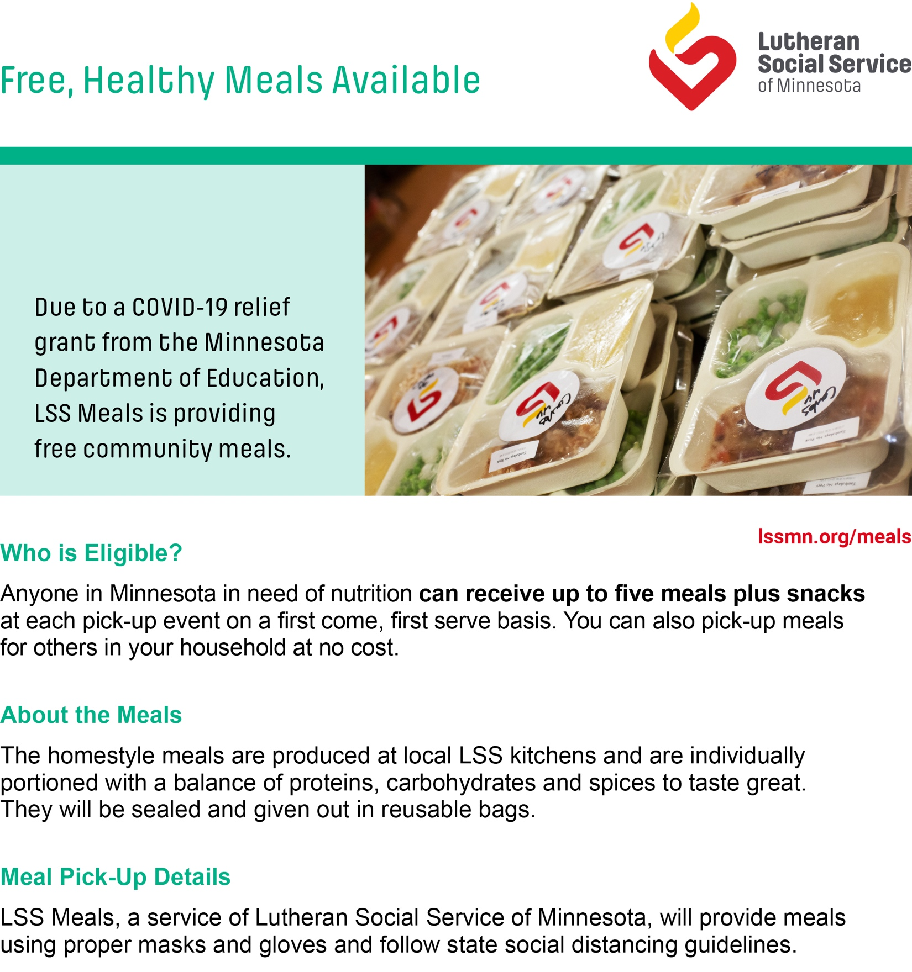
Date: 12/15/2020
Time: 3PM to 5PM
Location: Jeremiah Program Saint Paul, Address: 932 Concordia Ave, St Paul, MN 55104
If you have questions, please contact: Dalton Kalina 651-272-8693 or Dalton.Kalina@lssmn.org

