More Than Just Treading Water: How to Survive and Grow as a Law School Parent Right Now

Date & Time
March 19, 1pm Pacific; 4pm Eastern

Location & Registration
Zoom (please register via Zoom to receive the webinar link) https://sandiego.zoom.us/webinar/register/WN_7Nk1H0Y7RD-mRAdu9G-ocQ

The University of San Diego School of Law, Fordham Law School, and our partner institutions invite you to join us for a special program on parenting and caretaking while in law school. Parenting or caretaking, while simultaneously attending law school, presents a host of unique challenges for law students, and those challenges have only been compounded during the pandemic. In this program Lauren Smith Brody, author and creator of The Fifth Trimester, will share strategies that will enable law school parents and caretakers to not just survive but thrive in law school.
Brody will discuss strategies for:
- Working remotely with children at home, including:
  - Tactics for your productivity and mental health amid the chaos
  - Evidence-based ideas for protecting your kids' wellbeing
- Protecting and maintaining your equality -- at school and at home, through:
  - Solutions for guarding your time, business development, and future income
  - Plans for creating a fair division of labor in two-parent homes; and
- Negotiating now -- determining what we should keep from this temporary new normal by:
  - Helping our schools and workforce evolve in mutually beneficial ways
  - Contextualizing this moment in your larger career and for your future clients
For more information on Lauren Smith Brody please visit prhspeakers.com.
To purchase The Fifth Trimester: The Working Mom’s Guide to Style, Sanity, and Success After Baby visit penguinrandomhouse.com/books/536970/the-fifth-trimester-by-lauren-smith-brody/
About Lauren Smith Brody
Lauren Smith Brody is the founder of The Fifth Trimester movement and consulting, which supports working parents to advance women’s leadership and foster gender equality in the workforce.

Her book, The Fifth Trimester: The Working Mom’s Guide to Style, Sanity, and Success After Baby (Doubleday/Anchor), was a simultaneous best-seller in the Amazon categories of motherhood, women and business, and cultural anthropology. The Fifth Trimester has been featured in The New York Times and The Wall Street Journal, and on Good Morning America, CNN.com, and dozens more outlets, and Brody has been a featured speaker at companies and organizations including Amazon, Facebook, Fried Frank, Google, American Express, GLG, Rackspace, Liberty Mutual, PwC, The Wharton Women’s Summit, and more.

As an entrepreneur who can’t quit journalism, Brody writes regularly about the intersection of business and motherhood for, among others, The New York Times, Slate, and Elle, and pens monthly advice columns for Parade Media and the children’s brand Maisonette. She is also on the board of the early education nonprofit Docs for Tots. A longtime leader in the women’s magazine industry, Brody was previously the executive editor of Glamour magazine. Raised in Ohio, Texas, and Georgia, she now lives in New York City with her husband, two sons, and a joyfully neurotic rescue dog.

Co-sponsoring Institutions
This event is jointly sponsored by:
University of San Diego School of Law
Fordham Law School
Columbus School of Law
Pace Law School
Mitchell Hamline School of Law
Hofstra Law School
University of California, Davis School of Law
Miami Law School
University of Washington School of Law
University of Arkansas Little Rock Bowen School of Law
Suffolk University School of Law
University of Denver Sturm College of Law
Roger Williams University School of Law
Penn State Dickinson Law
University of the Pacific, McGeorge School of Law
University of California Hastings College of the Law

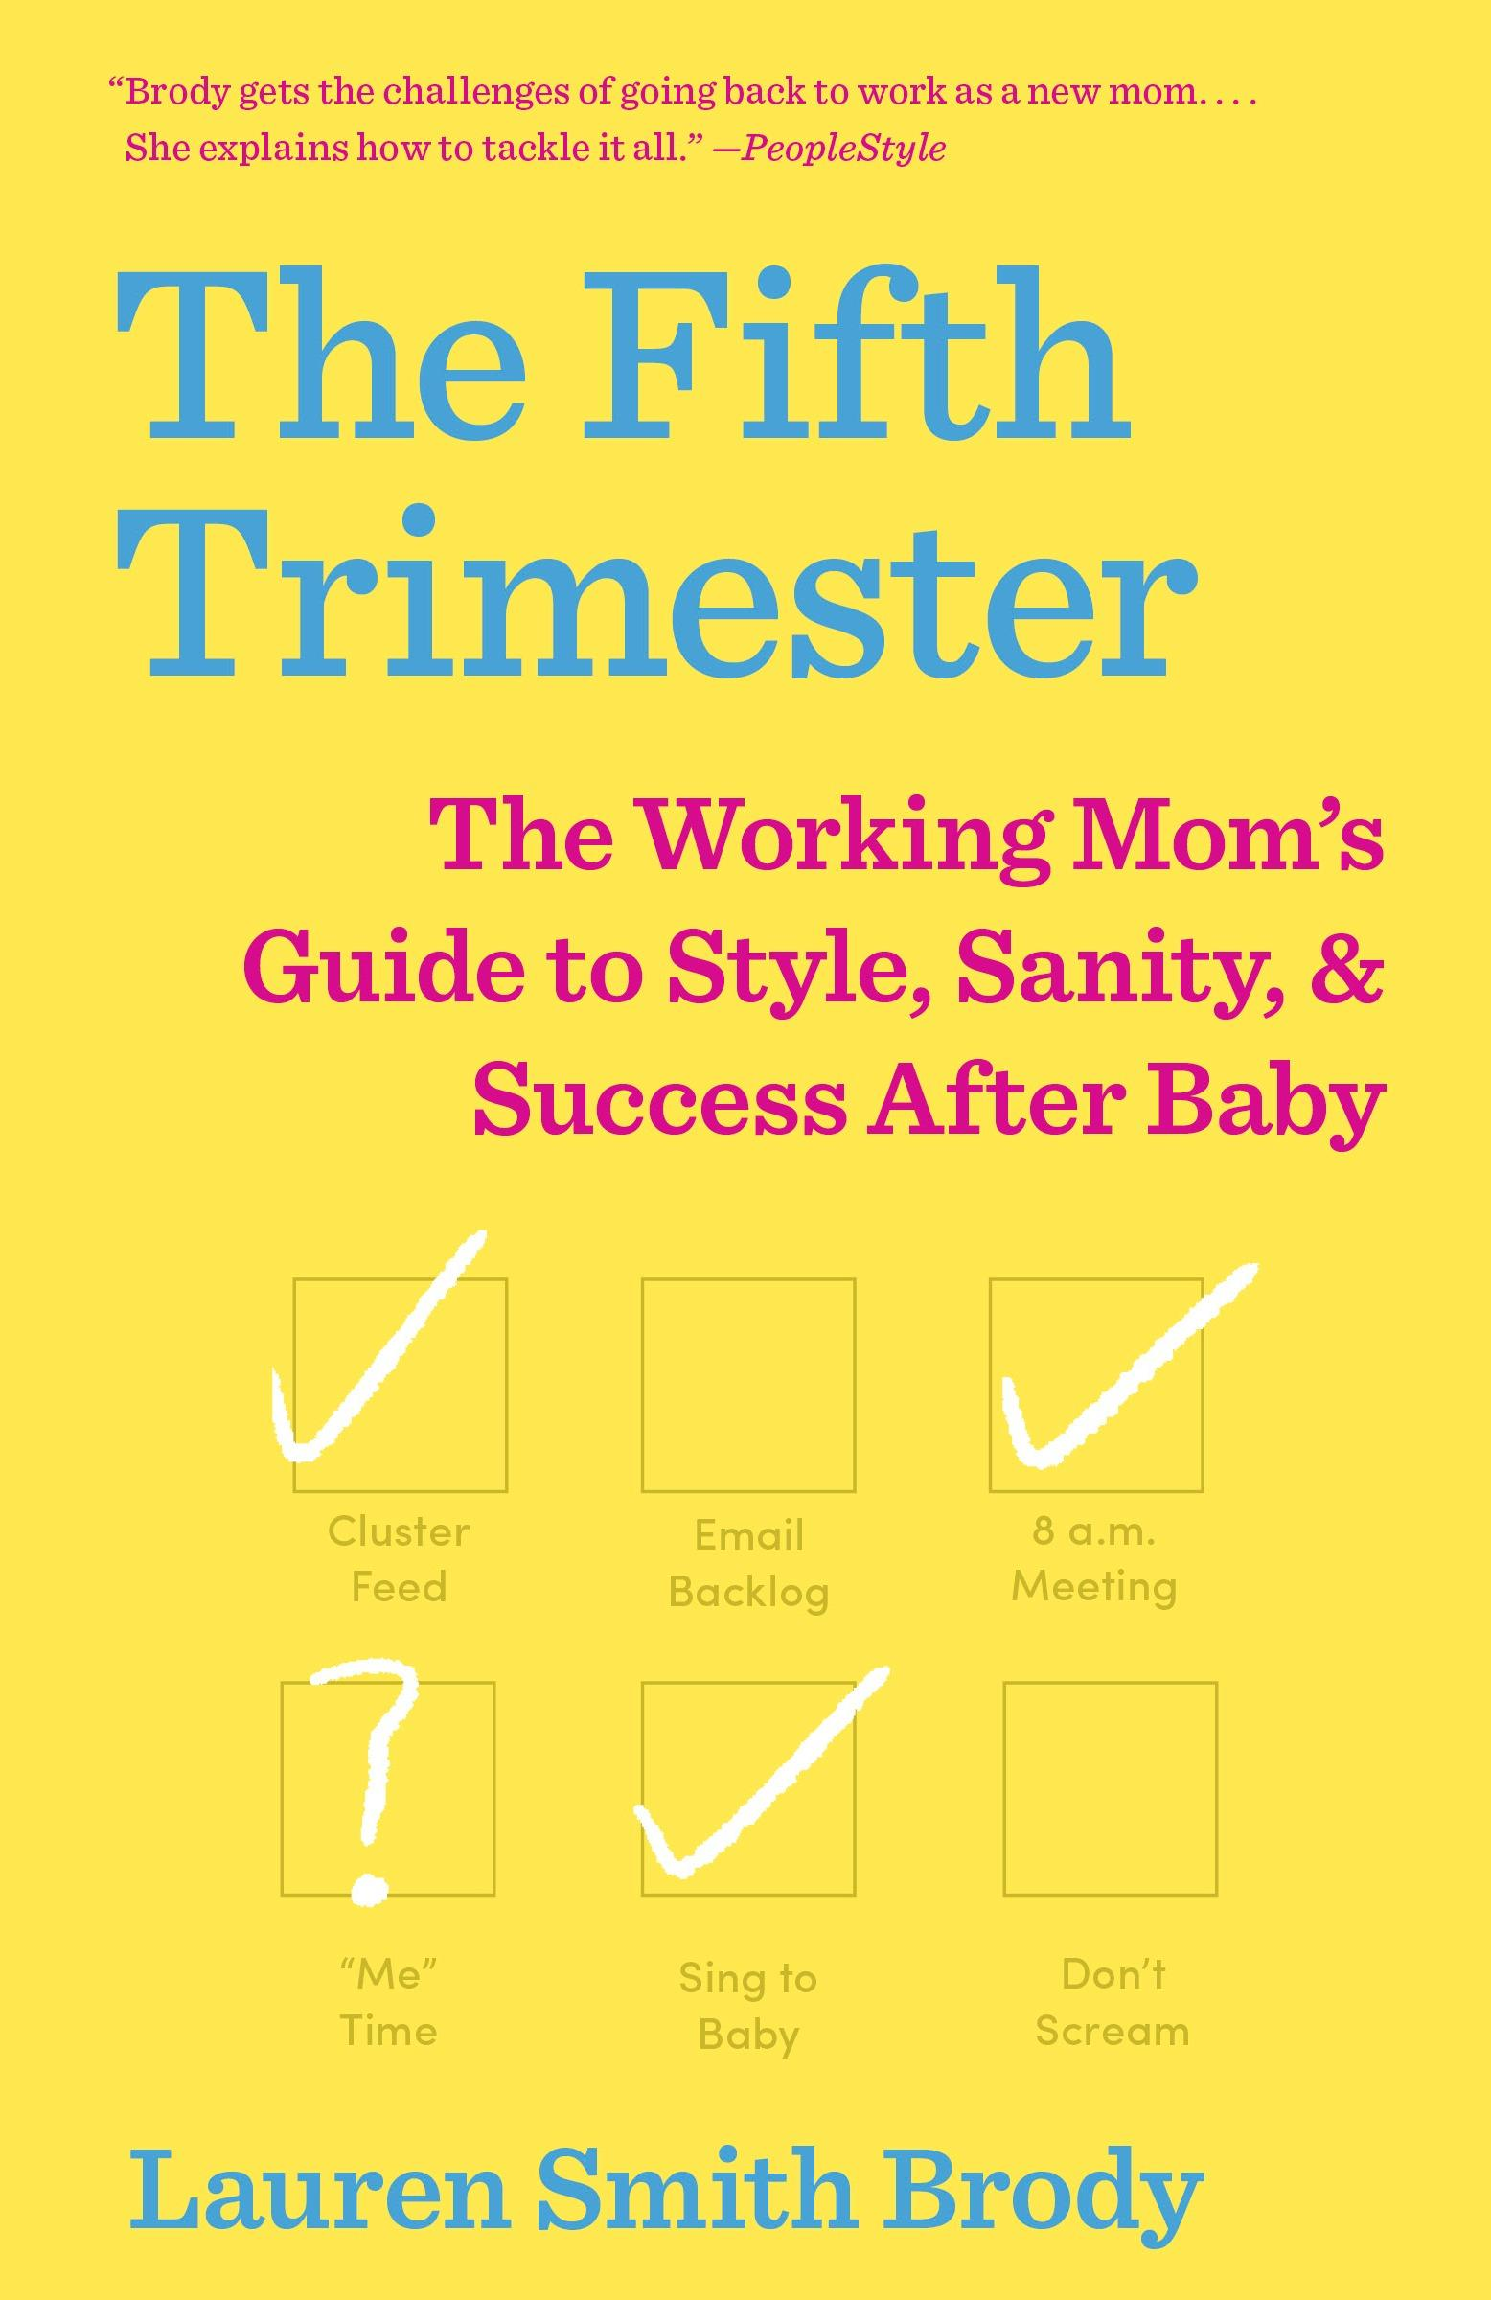
Social Media Post
Caption: The University of San Diego School of Law, Fordham Law School, and our partner institutions invite you to join us for a special program on parenting and caretaking while in law school on Friday, March 19 at 1:00pm (PDT). Parenting or caretaking, while simultaneously attending law school, presents a host of unique challenges for law students, and those challenges have only been compounded during the pandemic. In this program Lauren Smith Brody, author and creator of The Fifth Trimester, will share strategies that will enable law school parents and caretakers to not just survive but thrive in law school. Register to attend via Zoom here: https://tinyurl.com/2b2dmpvk
For more information on Lauren Smith Brody please visit prhspeakers.com.

