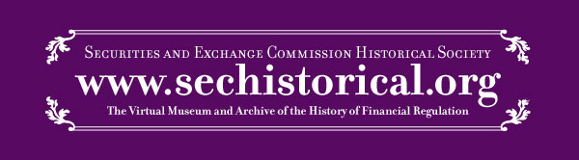
2017 Writing Competition – Invitation to Your Students

To: Professor Z. Jill Barclift

From: David Lipton, Professor of Law, The Catholic University of America; Trustee and Vice President-
Museum, SEC Historical Society
Michael Ryan, Adjunct Professor of Law, The Catholic University of America

Date: July 25, 2016

Your students are invited to join in the 2017 writing competition of www.sechistorical.org, the virtual museum and archive of the history of financial regulation, administered and built by the SEC Historical Society.

The virtual museum and archive at www.sechistorical.org is the preeminent source for trusted and verified information on the regulation of the capital markets from the 20th century to the present. Each day, thousands of visitors come to www.sechistorical.org, including regulators, self-regulators, practitioners and members of our academic community. The virtual museum and archive is separate from and independent of the U.S. Securities and Exchange Commission.

Paper(s) deemed of quality by you should be sent to curator@sechistorical.org. Submissions will be reviewed by an independent SEC Historical Society panel, consisting of prominent attorneys and scholars, and coordinated by Professor Lipton. Winning submissions will be placed for a period of time in a dedicated section on www.sechistorical.org. Up to two winning papers will each receive a $5,000 award. The review panel retains the right to determine that there are no papers of appropriate excellence submitted and to refrain from selecting a winner from the papers submitted.

Guidelines
- The competition is open to all students.
- The paper will be on any topic in securities regulation. Use of material currently in the collection of www.sechistorical.org is encouraged but not required.
- The paper will be in English. There is no required word length, but expectations are that the paper will be between five and 30 typed pages, double-spaced, with normal margins on 8 ½ x 11” paper.
- The paper will be original, and not as yet published in any print or electronic format.
- Submissions will be made to you by your students by December 31, 2016. You will review entries and submit any papers you deem worthy of review, with author contact information, to curator@sechistorical.org by January 31, 2017.
- The independent review panel, coordinated by Professor Lipton, will review all submissions by March 31, 2017, and determine papers qualifying for awards. The panel reserves the right not to make awards.
- Authors of winning papers will be notified by Professor Lipton. You will be informed if any of your students receives an award.

We look forward to your assistance in sharing this notice and encouraging your students to participate. For further information, please contact curator@sechistorical.org.

